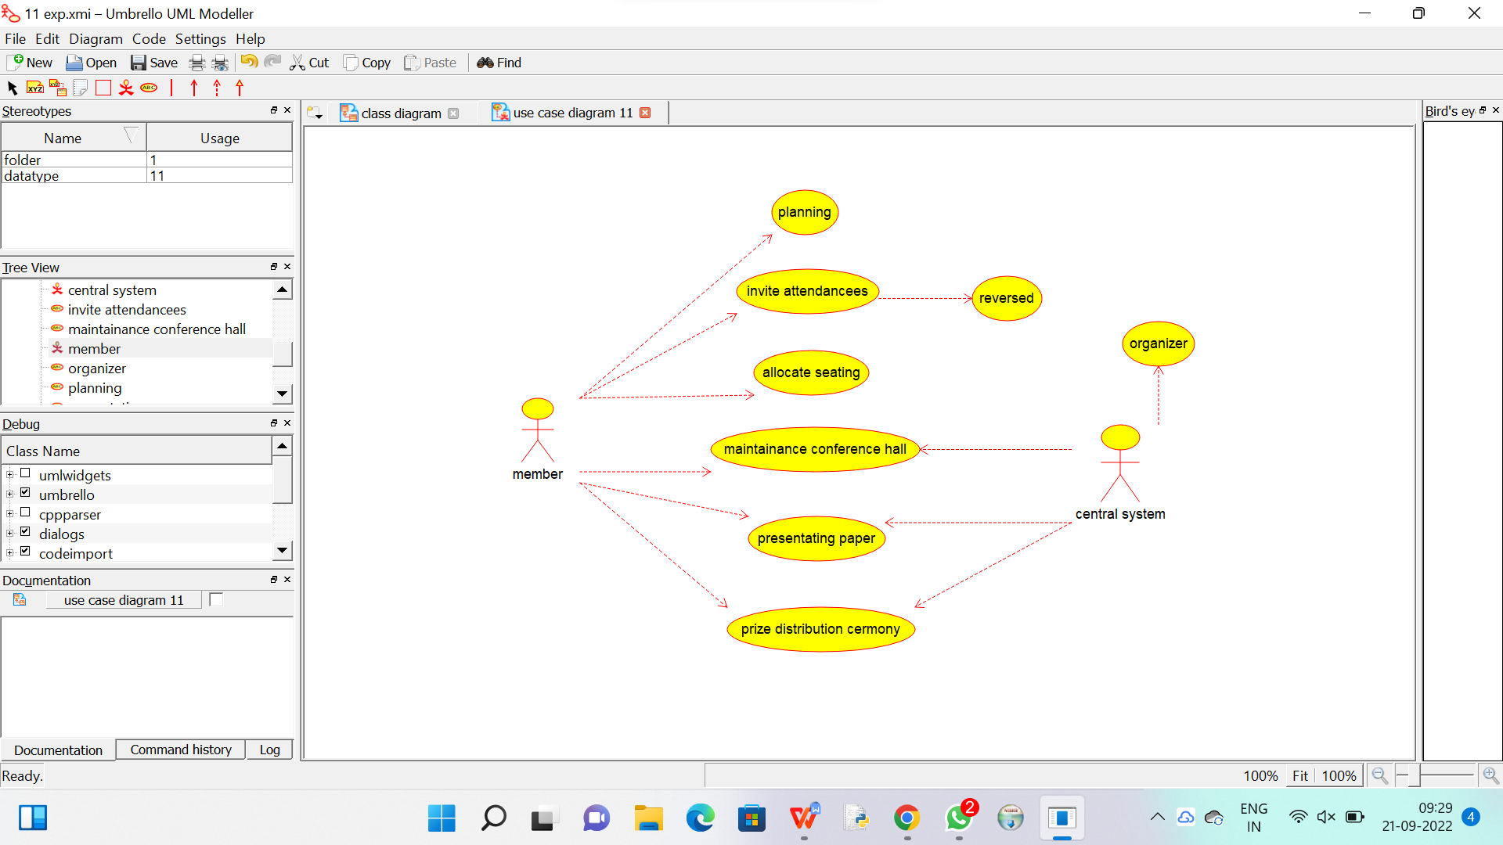

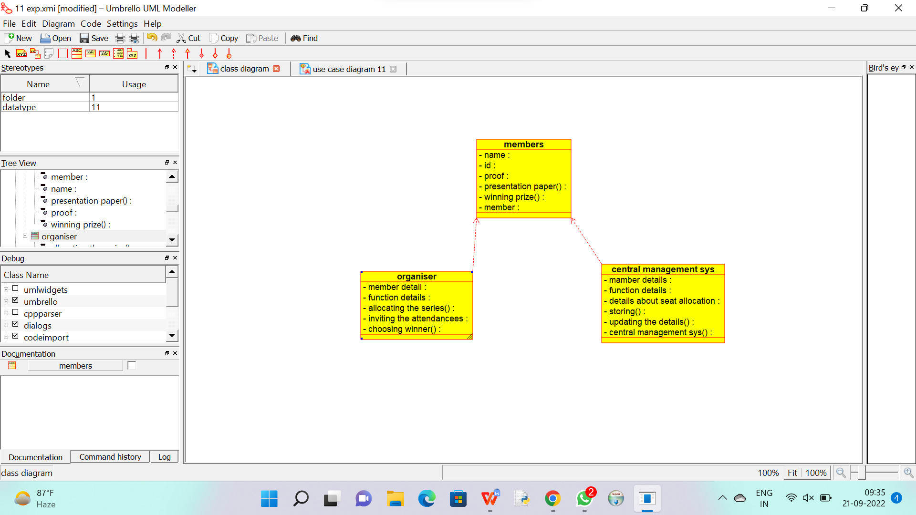

Code generation of member :

/**

 * Class members

 */

public class members {

  //

  // Fields

  //

  private void name;

  private void id;

  private void proof;

  private void presentation_paper_;

  private void winning_prize_;

  private void member;

  //

  // Constructors

  //

  public members () { };

  //

  // Methods

  //

  //

  // Accessor methods

  //

  /**

   * Set the value of name

   * @param newVar the new value of name

   */

  private void setName (void newVar) {

    name = newVar;

  }

  /**

   * Get the value of name

   * @return the value of name

   */

  private void getName () {

    return name;

  }

  /**

   * Set the value of id

   * @param newVar the new value of id

   */

  private void setId (void newVar) {

    id = newVar;

  }

  /**

   * Get the value of id

   * @return the value of id

   */

  private void getId () {

    return id;

  }

  /**

   * Set the value of proof

   * @param newVar the new value of proof

   */

  private void setProof (void newVar) {

    proof = newVar;

  }

  /**

   * Get the value of proof

   * @return the value of proof

   */

  private void getProof () {

    return proof;

  }

  /**

   * Set the value of presentation_paper_

   * @param newVar the new value of presentation_paper_

   */

  private void setPresentation_paper_ (void newVar) {

    presentation_paper_ = newVar;

  }

  /**

   * Get the value of presentation_paper_

   * @return the value of presentation_paper_

   */

  private void getPresentation_paper_ () {

    return presentation_paper_;

  }

  /**

   * Set the value of winning_prize_

   * @param newVar the new value of winning_prize_

   */

  private void setWinning_prize_ (void newVar) {

    winning_prize_ = newVar;

  }

  /**

   * Get the value of winning_prize_

   * @return the value of winning_prize_

   */

  private void getWinning_prize_ () {

    return winning_prize_;

  }

  /**

   * Set the value of member

   * @param newVar the new value of member

   */

  private void setMember (void newVar) {

    member = newVar;

  }

  /**

   * Get the value of member

   * @return the value of member

   */

  private void getMember () {

    return member;

  }

  //

  // Other methods

  //

}

Code generation of organiser :

/**

 * Class organiser

 */

public class organiser {

  //

  // Fields

  //

  private void member_detail;

  private void function_details;

  private void allocating_the_series_;

  private void inviting_the_attendancees;

  private void choosing_winner_;

  //

  // Constructors

  //

  public organiser () { };

  //

  // Methods

  //

  //

  // Accessor methods

  //

  /**

   * Set the value of member_detail

   * @param newVar the new value of member_detail

   */

  private void setMember_detail (void newVar) {

    member_detail = newVar;

  }

  /**

   * Get the value of member_detail

   * @return the value of member_detail

   */

  private void getMember_detail () {

    return member_detail;

  }

  /**

   * Set the value of function_details

   * @param newVar the new value of function_details

   */

  private void setFunction_details (void newVar) {

    function_details = newVar;

  }

  /**

   * Get the value of function_details

   * @return the value of function_details

   */

  private void getFunction_details () {

    return function_details;

  }

  /**

   * Set the value of allocating_the_series_

   * @param newVar the new value of allocating_the_series_

   */

  private void setAllocating_the_series_ (void newVar) {

    allocating_the_series_ = newVar;

  }

  /**

   * Get the value of allocating_the_series_

   * @return the value of allocating_the_series_

   */

  private void getAllocating_the_series_ () {

    return allocating_the_series_;

  }

  /**

   * Set the value of inviting_the_attendancees

   * @param newVar the new value of inviting_the_attendancees

   */

  private void setInviting_the_attendancees (void newVar) {

    inviting_the_attendancees = newVar;

  }

  /**

   * Get the value of inviting_the_attendancees

   * @return the value of inviting_the_attendancees

   */

  private void getInviting_the_attendancees () {

    return inviting_the_attendancees;

  }

  /**

   * Set the value of choosing_winner_

   * @param newVar the new value of choosing_winner_

   */

  private void setChoosing_winner_ (void newVar) {

    choosing_winner_ = newVar;

  }

  /**

   * Get the value of choosing_winner_

   * @return the value of choosing_winner_

   */

  private void getChoosing_winner_ () {

    return choosing_winner_;

  }

  //

  // Other methods

  //

}

Code generation of central management system :

/**

 * Class central_management_sys

 */

public class central_management_sys {

  //

  // Fields

  //

  private void mamber_details;

  private void function_details;

  private void details_about_seat_allocation;

  private void storing_;

  private void updating_the_details_;

  private void central_management_sys_;

  //

  // Constructors

  //

  public central_management_sys () { };

  //

  // Methods

  //

  //

  // Accessor methods

  //

  /**

   * Set the value of mamber_details

   * @param newVar the new value of mamber_details

   */

  private void setMamber_details (void newVar) {

    mamber_details = newVar;

  }

  /**

   * Get the value of mamber_details

   * @return the value of mamber_details

   */

  private void getMamber_details () {

    return mamber_details;

  }

  /**

   * Set the value of function_details

   * @param newVar the new value of function_details

   */

  private void setFunction_details (void newVar) {

    function_details = newVar;

  }

  /**

   * Get the value of function_details

   * @return the value of function_details

   */

  private void getFunction_details () {

    return function_details;

  }

  /**

   * Set the value of details_about_seat_allocation

   * @param newVar the new value of details_about_seat_allocation

   */

  private void setDetails_about_seat_allocation (void newVar) {

    details_about_seat_allocation = newVar;

  }

  /**

   * Get the value of details_about_seat_allocation

   * @return the value of details_about_seat_allocation

   */

  private void getDetails_about_seat_allocation () {

    return details_about_seat_allocation;

  }

  /**

   * Set the value of storing_

   * @param newVar the new value of storing_

   */

  private void setStoring_ (void newVar) {

    storing_ = newVar;

  }

  /**

   * Get the value of storing_

   * @return the value of storing_

   */

  private void getStoring_ () {

    return storing_;

  }

  /**

   * Set the value of updating_the_details_

   * @param newVar the new value of updating_the_details_

   */

  private void setUpdating_the_details_ (void newVar) {

    updating_the_details_ = newVar;

  }

  /**

   * Get the value of updating_the_details_

   * @return the value of updating_the_details_

   */

  private void getUpdating_the_details_ () {

    return updating_the_details_;

  }

  /**

   * Set the value of central_management_sys_

   * @param newVar the new value of central_management_sys_

   */

  private void setCentral_management_sys_ (void newVar) {

    central_management_sys_ = newVar;

  }

  /**

   * Get the value of central_management_sys_

   * @return the value of central_management_sys_

   */

  private void getCentral_management_sys_ () {

    return central_management_sys_;

  }

  //

  // Other methods

  //

}